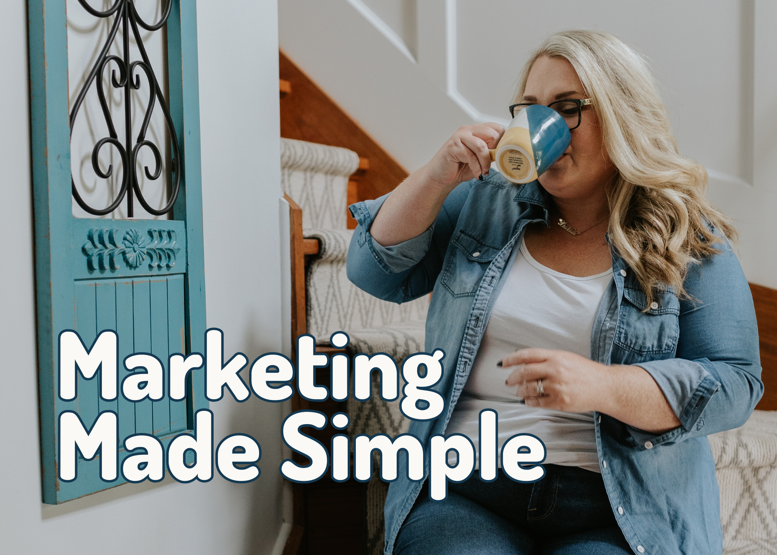

5 Emails You Can Send Your List This Month
For B2B, B2C, service providers, retail shops, restaurants, local businesses, online businesses — anyone with an audience.
Each email includes:
- Purpose
- Who it works for
- What to include
- Copy/paste template you can customize in 60 seconds
Before you start, make sure you save your own copy of this document so you can edit it.

Here’s how:
1️⃣ Click File
2️⃣ Click “Make a copy”
3️⃣ Save it to your Google Drive with a name like Email Ideas - [Month]
4️⃣ Edit any of the fill-in-the-blank sections
5️⃣ Copy + paste each email into your email platform when you’re ready to send it

That’s it — simple and done.

You can send these emails exactly as written, or tweak the tone to match your brand. The goal isn’t perfection — it’s connection, consistency, and staying top-of-mind with the people who want to hear from you.

If you send even one email per week, you’ll be ahead of 90% of businesses.

The “Story With a Point” Email
Purpose: Build connection + trust

Works For: Every single business type

What to include:
- A short story (something that happened recently)
- What you learned
- Why it matters to your audience

Copy + Paste Template:
Subject: I didn’t expect this to happen…
Something happened this week that made me stop and think.
[Insert short story: something small, relatable, or funny.]
Here’s what it reminded me of:
[Insert lesson that ties back to your industry, values, or customer experience.]
I wanted to share it with you in case you needed the reminder too.
Thanks for being here — it means more than you know.

The “Here’s How to Make Your Life Easier” Email
Purpose: Deliver instant value

Works For:
- Retail (tips on using product)
- Restaurants (recipes, insider tricks)
- Service providers (how-to steps)
- B2B (efficiency tips)
What to include:
- A quick tip
- Why it works
- How they can try it today

Copy + Paste Template:
Subject: A quick tip that will save you time ⏳
If you’re looking for something you can do today that makes a real difference, here it is:
[Insert tip.]
Why it works:
[Explain why it's helpful.]
If you try it this week, hit reply and let me know how it goes — I love hearing your wins.

The “Behind the Scenes” Email

Purpose: Build familiarity + humanize your brand

Works For: Everyone. This email ALWAYS performs well.

What to include:
- Show what you're working on
- Share the process
- Tie it back to how it helps your audience

Copy + Paste Template:
Subject: A little behind the scenes 👀
I wanted to give you a peek into what’s been happening over here.
Lately, I’ve been working on:
• [Project #1]
• [Project #2]
• [Project #3]
Here’s why I’m excited about it:
[Explain the benefit to them.]
If you like these behind-the-scenes updates, I’ll keep them coming!

The “Helpful Resource” Email

Purpose: Become the go-to expert

Works For: B2B, B2C, services, retail, creators, trades — ANYONE who wants to show leadership in their niche.

What to include:
- A link or recommendation
- Why you like it
- How it helps your audience

Copy + Paste Template:
Subject: I thought you might like this 🔗
I came across something that could be really helpful for you:
👉 [Insert resource: article, tool, video, checklist, local event]
Here’s why I love it:
[Insert benefit.]
If you use it, let me know what you think — I always love sharing good finds with this community.

The “Soft Offer Reminder” Email

Purpose: Sell without sounding salesy

Works For: Anyone with a product, service, workshop, subscription, or store.

What to include:
- Who you help
- What problem you solve
- How they can take the next step

Copy + Paste Template:
Subject: In case you didn’t know…
I realized I haven’t shared this in a while — so here’s a quick reminder of how I can help:
If you’re dealing with ___
And you want ___
Here’s what I offer:
[Insert offer in 1–2 lines.]
No pressure, just information.
If it’s something you’ve been thinking about, you can learn more here: [Link]
And if not, that’s okay — I’ll keep sending helpful ideas your way.

Want more practical marketing ideas like this? Come hang out with me on Instagram — that’s where I share the good stuff.

And if you’re ready to level up your marketing in a real, sustainable way, send me a message at info@simpledesksolutions.ca . Let’s make your next stage of growth the easiest one yet.

